Practical - 6
Practical Title: Rendering External JSON Data using Fetch API, Search and Filter
Problem Definition: Display event lists, student profiles, notices, or FAQs from external JSON files using Fetch API. Implement dynamic rendering, search, filter, sorting, and pagination.

Theory

How is JSON fetched, parsed, and rendered?
Answer : JSON is fetched using fetch() and converted into JavaScript objects using .json(). The data is then displayed dynamically in HTML using JavaScript DOM methods.

Which array methods are used for search, filter, sort, and pagination?
Answer : filter() is used for search/filtering, sort() for sorting, and slice() for pagination. map() can be used to display the filtered data.

How are loading and error states handled?
Answer : A loading message is shown while JSON data is being fetched. catch() handles errors and displays an appropriate error message to the user.

How is modularity maintained in JavaScript files?
Answer : JavaScript is divided into separate files/functions for different features. This makes the code easier to manage, reuse, test, and maintain.

Implementation :
- HTML5: Created the structure and different pages of the StudentHub portal.
- CSS3: Applied responsive design, layout, colors, and styling.
- JavaScript: Added dynamic and interactive features.
- JSON: Fetched and parsed data using fetch() and .json().
- Array Methods: Used filter(), sort(), map(), and slice() for data handling.
- Loading & Error: Displayed loading messages and handled errors using catch().
- Modularity: Divided JavaScript code into separate functions/files for easy maintenance.

Evidence of Work (Screenshots)
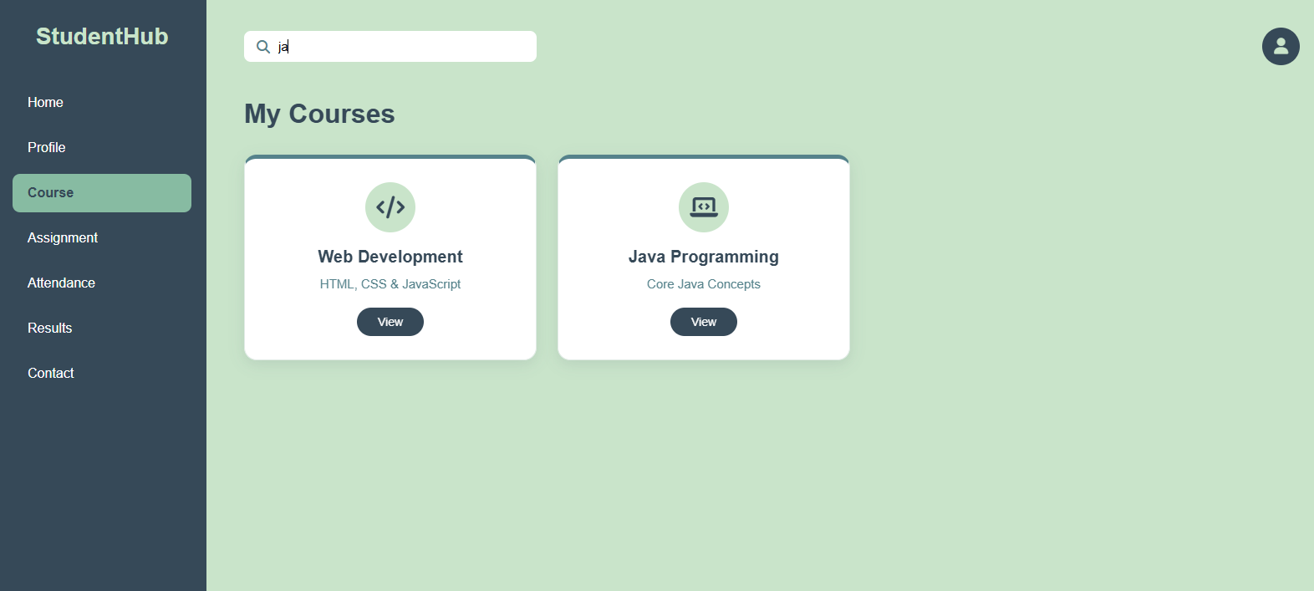
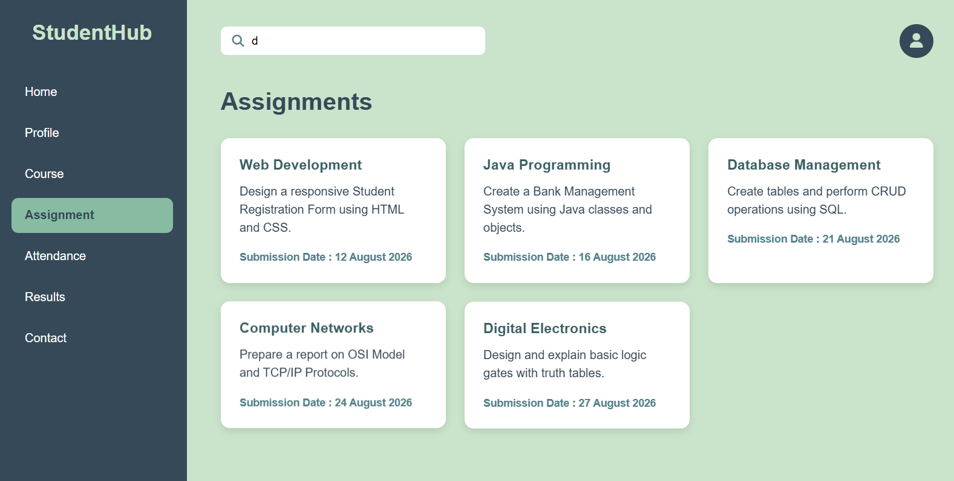
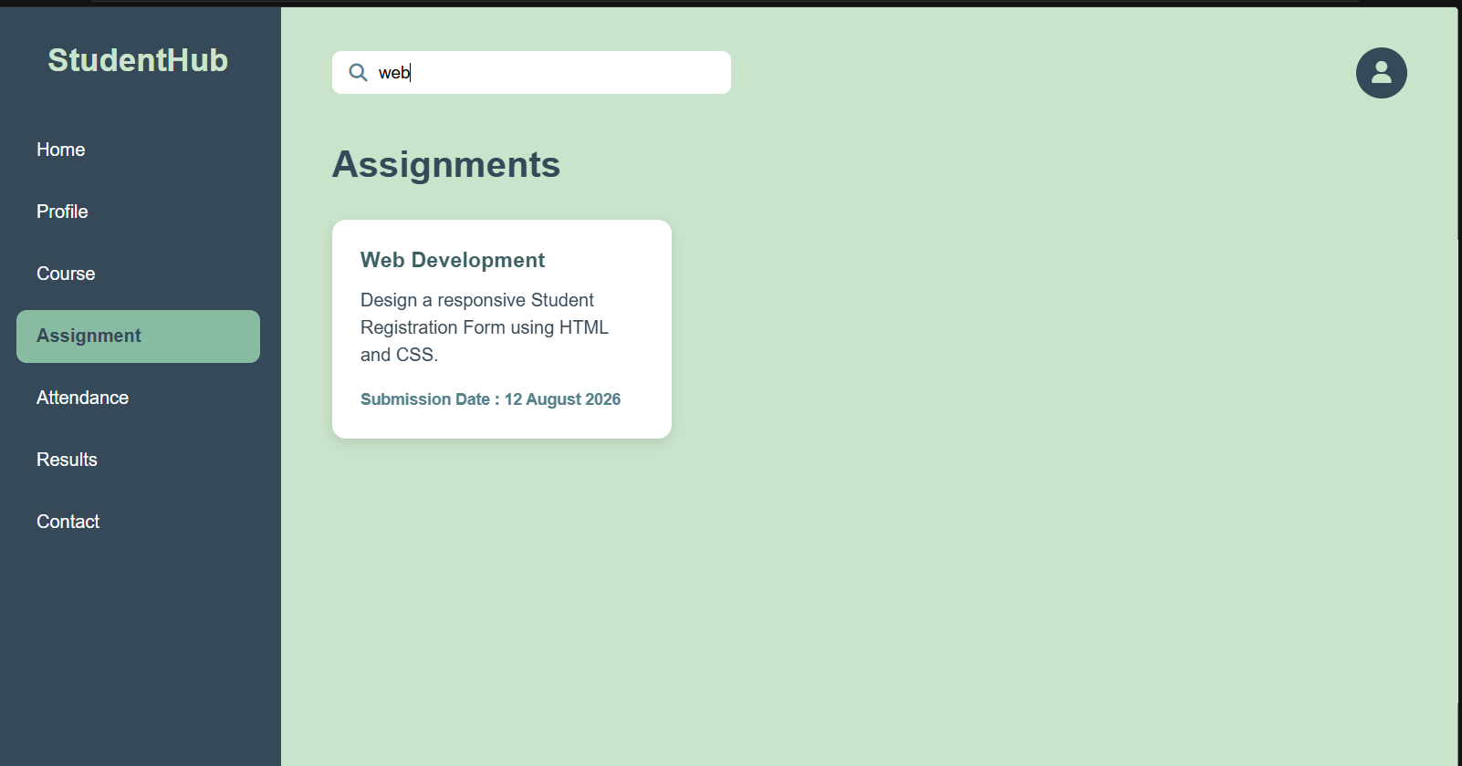
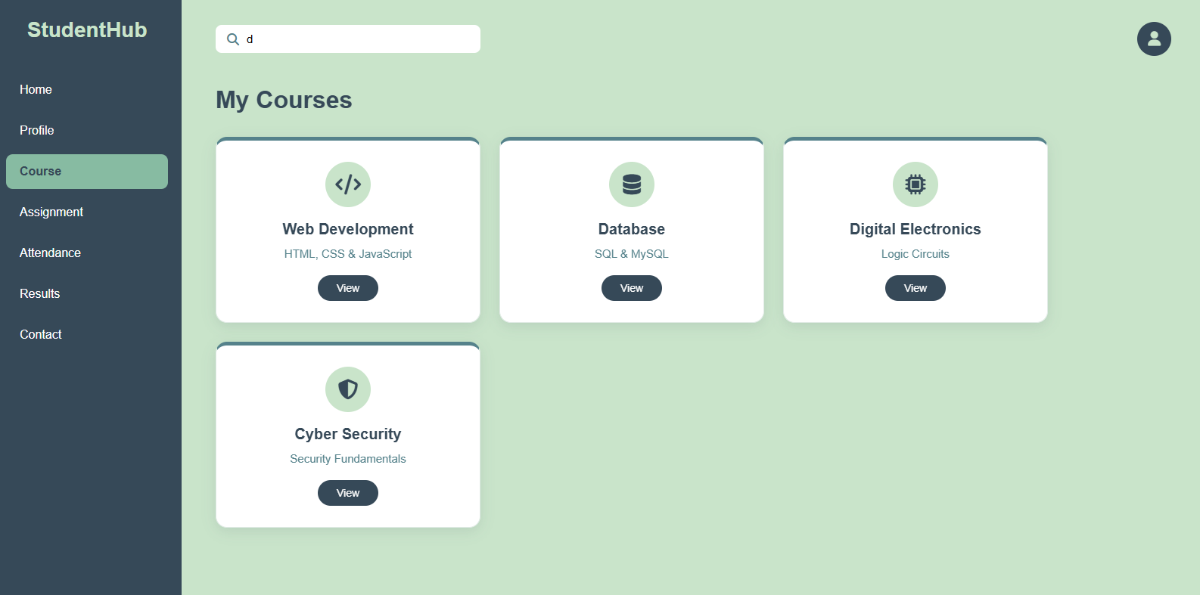

GitHub Repository Link:

https://github.com/fenikaila12/WDF/tree/main/Practical%206

Challenges Faced:
• Understanding how to fetch and parse JSON data.
• Implementing search, filter, sort, and pagination correctly.
• Handling loading and error messages.
• Managing JavaScript functions and multiple files.
• Making the webpage responsive and user-friendly.

Learning Outcomes:
• Learned how to use JSON data with JavaScript.
• Learned fetch(), filter(), sort(), map(), and slice().
• Learned to handle loading and error states.
• Improved JavaScript modularity and DOM manipulation skills.
• Learned to create dynamic and responsive web pages.

Faculty Remarks: (Keep this blank for faculty)

